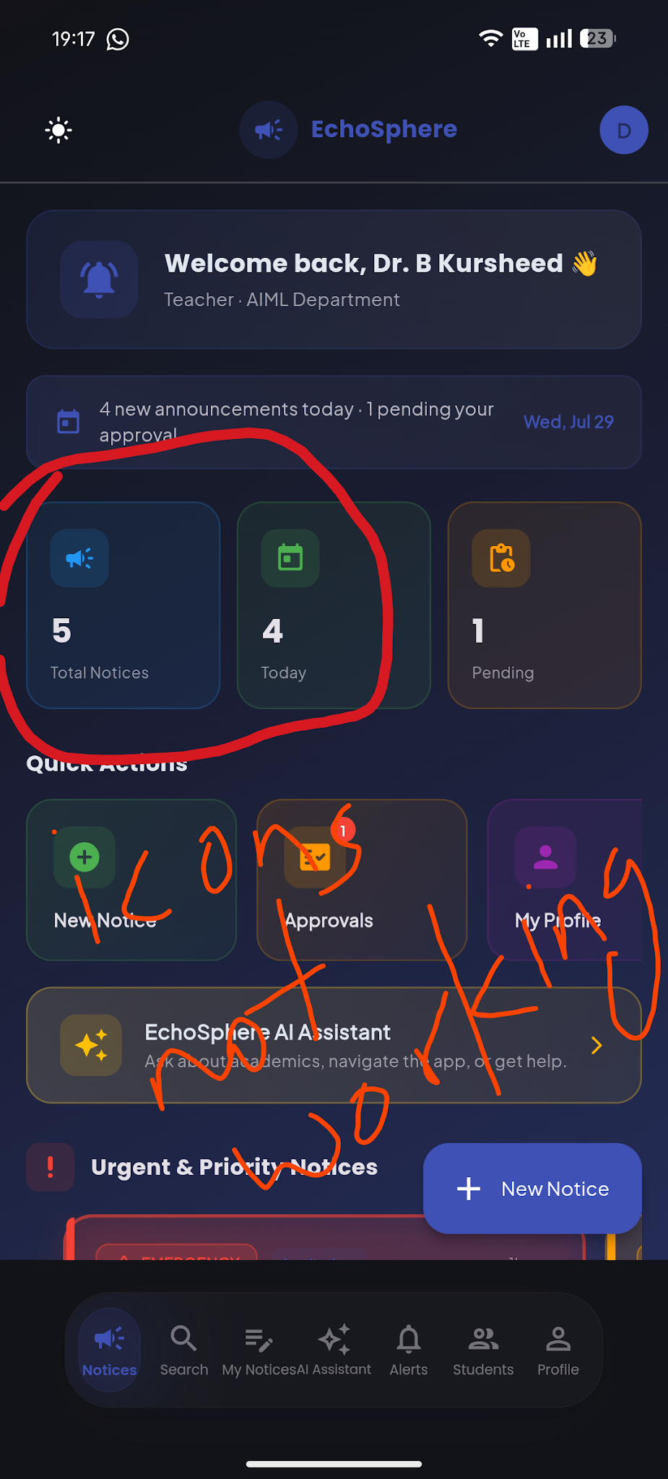

2…..Profile click madudre students page ge hogthide And overflow ede
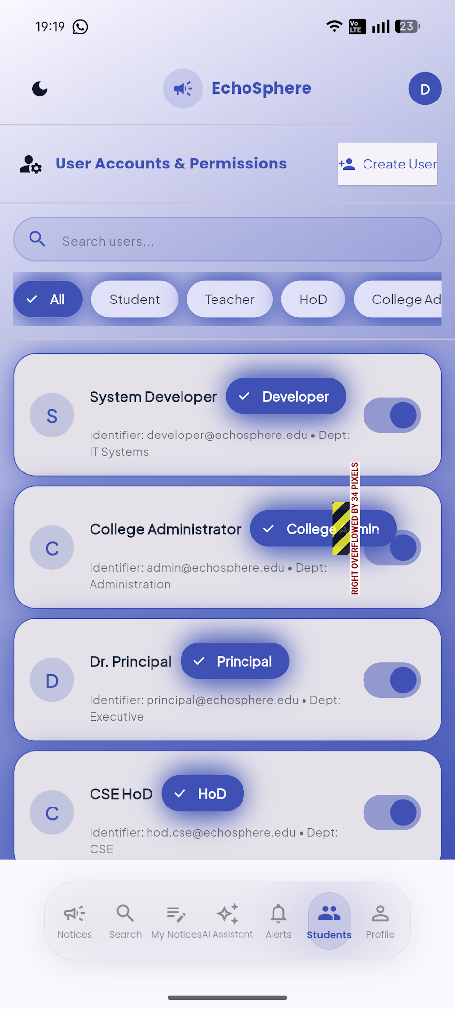

3……Can only review the notices and cannot take any actions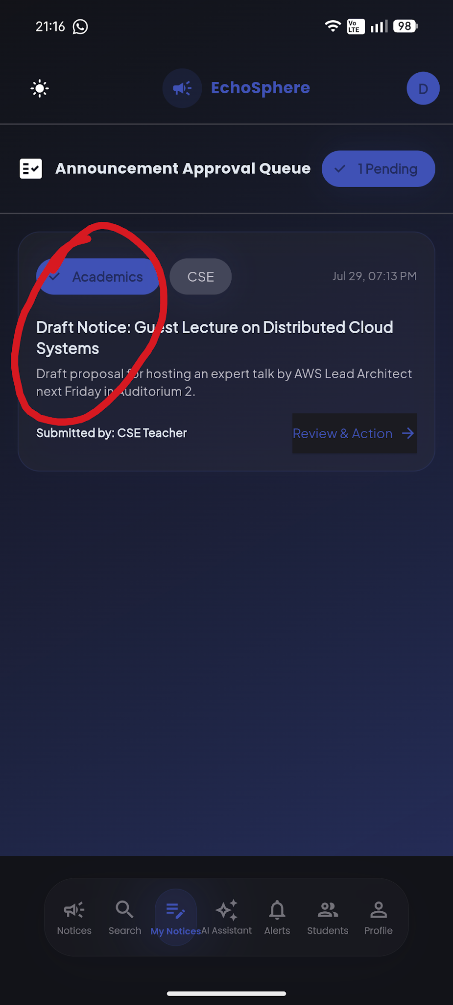

4…..approval not working properly taking to search page when clicked
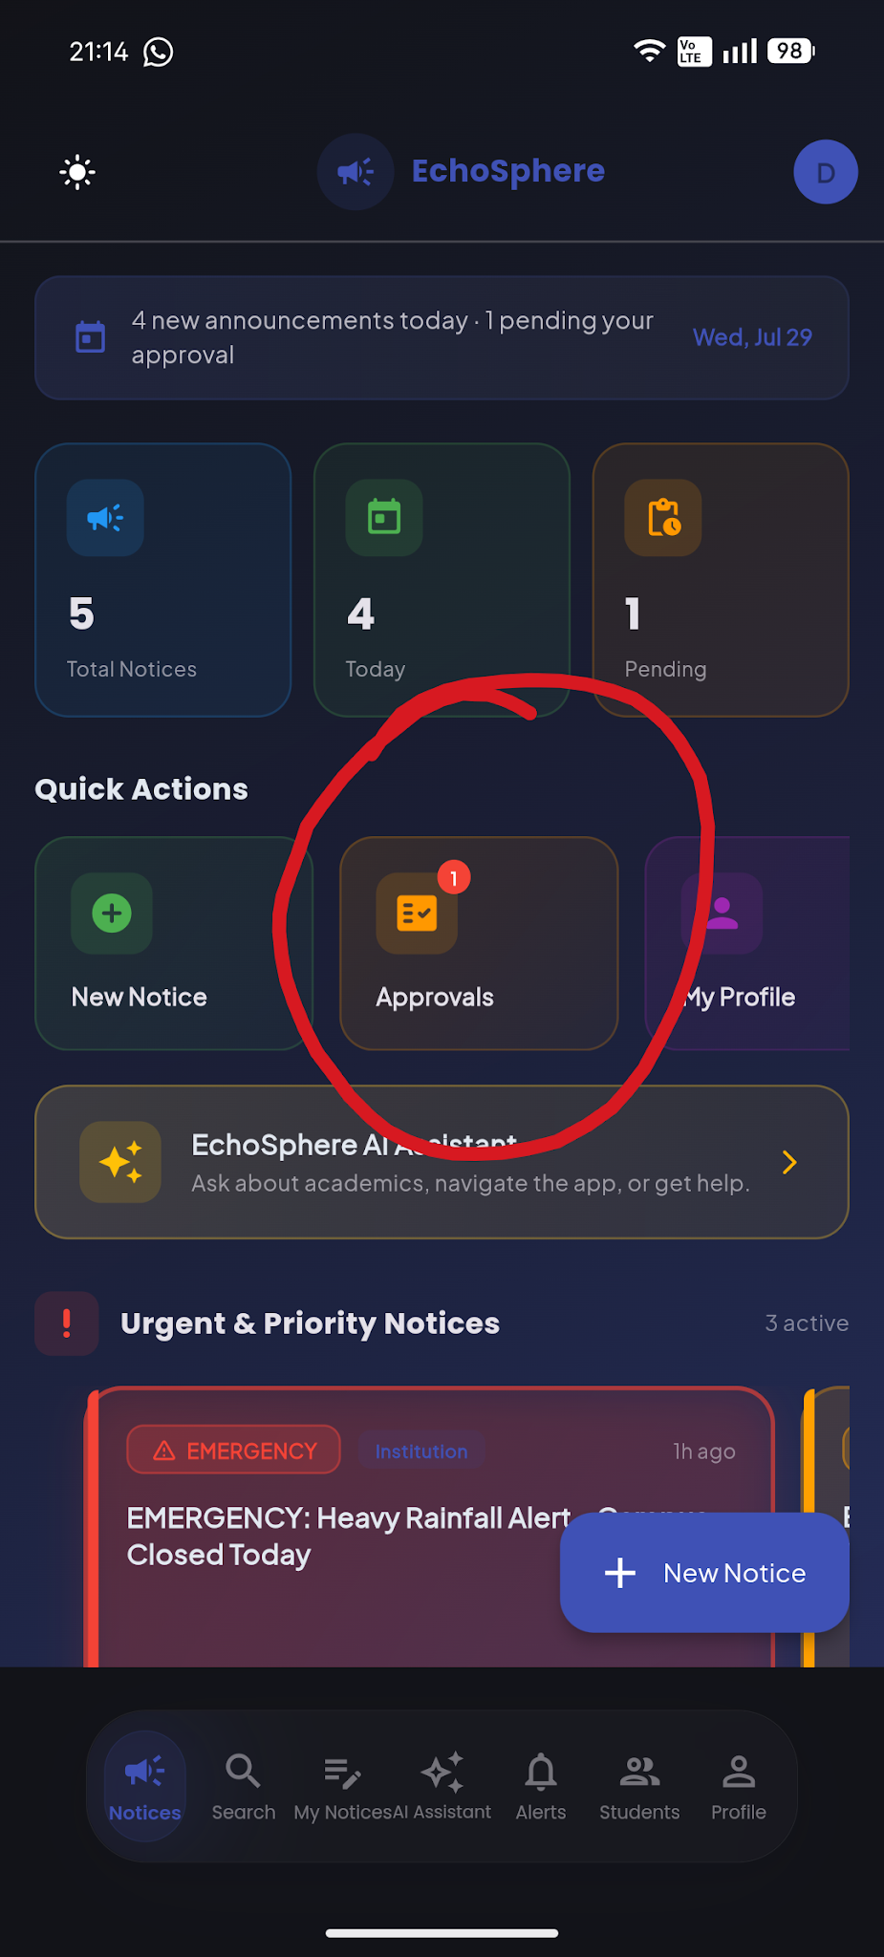

5……browse announcement and check categories are not working as required and are showing the same answer to both questions which are irrelevant
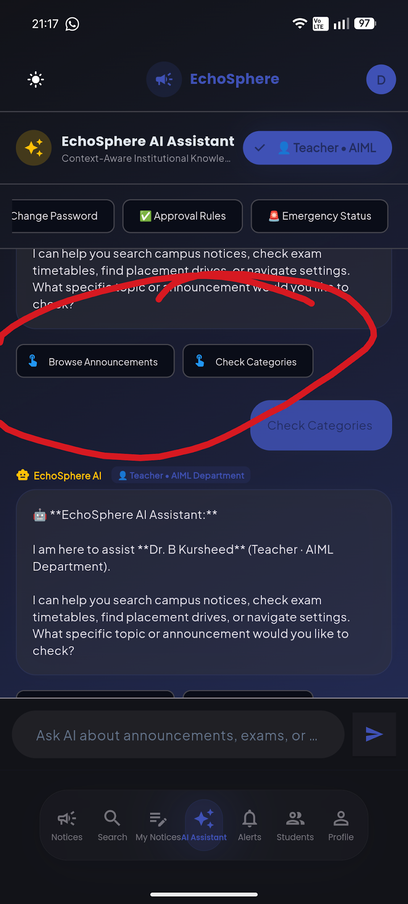

6….alerts not opening when clicked on
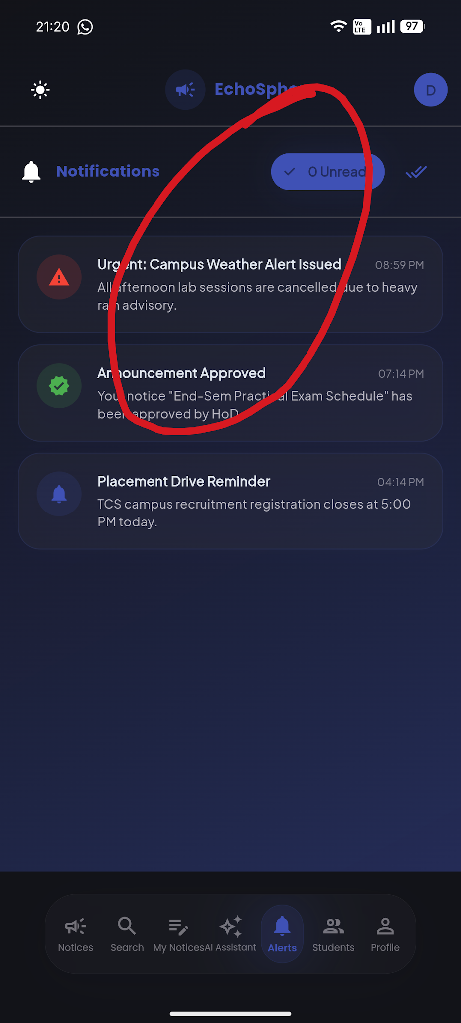

7….spacing not proper
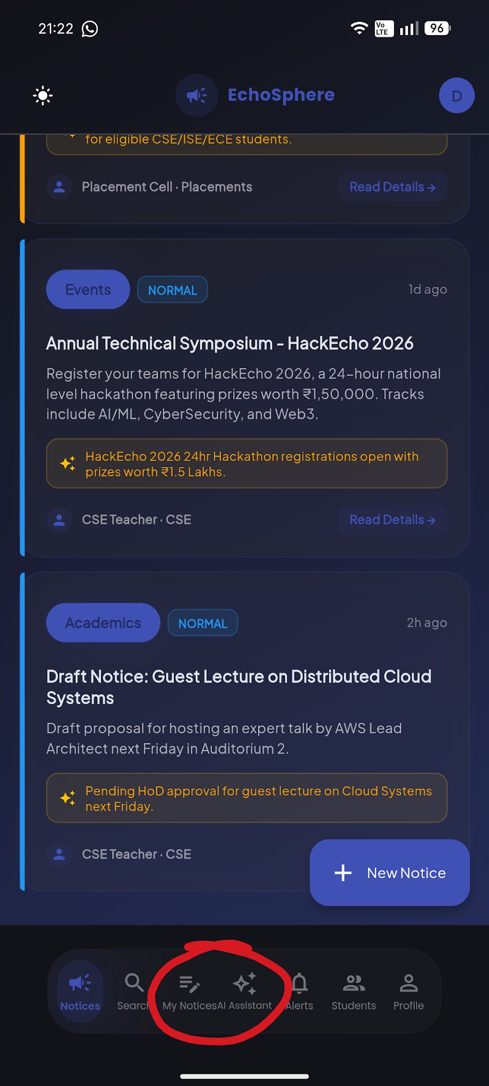

8….Admin page-new notice overflow